**Weekly Blog 3**

**Things that I have learnt:-**

I read three research papers related to the project , which are discussed later. Apart from that, I made my first rough wireframes for a mobile application.

Steps to create wireframes for mobile apps:-

1. Download a wireframing/prototyping software such as the Balsamiq wireframes
2. Choose a container to make the wireframes
3. Start from the landing page of the application and use text boxes, images to display what the expected basic structure of a page before visual design and content is added looks like.

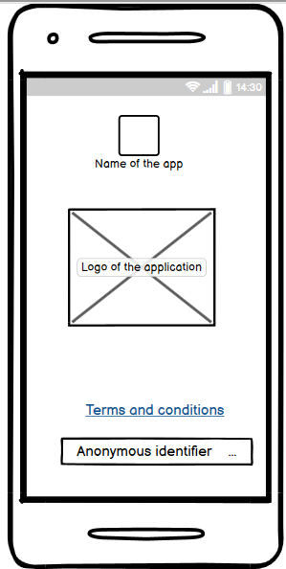

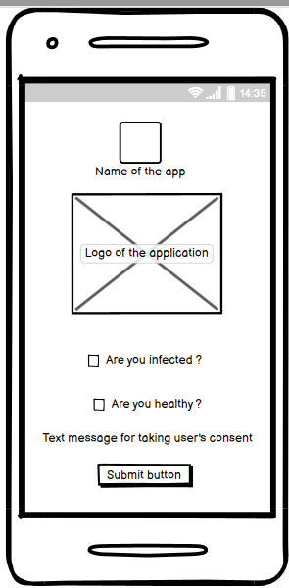

**Paper Review 1**

Li, Jinfeng & Guo, Xinyi. (2020). COVID-19 Contact-tracing Apps: A Survey on the Global Deployment and Challenges.

<https://www.researchgate.net/publication/341231023_COVID-19_Contact-tracing_Apps_A_Survey_on_the_Global_Deployment_and_Challenges>

**What research questions does the paper address?**

1. The authors discuss the deployment framework of the contact tracing apps i.e. centralised or decentralised , their advantages and disadvantages.
2. Following a software vulnerability-mapping analysis paradigm, the flaws of 10 contact-tracing Apps are analysed and summarised.
3. Identifying the Challenges and Research Directions for Bluetooth based Contact Tracking Technologies.

**What was the conclusion on the research?**

The decentralised and no GPS solution provides the highest level of data protection for individuals as no personal data is collected unless the individual is infected. Also, Without the GPS tracking, Apps cannot collect and trace the movement of the population geographically. With a decentralised framework, however, any data collected from individuals cannot be driven into a centralised database for future analysis, i.e. less information will be provided to the government. Also, after studying the 10 most popular contact tracing systems, Health Code on Alipay and WeChat was found to be covering the highest amount of population i.e. 63%.

**How can you apply this knowledge to your project?**

This paper helps in getting a broader idea about the data regulations and the technology protocols that can be employed in our solution application. Also the first geolocation mapping for the global deployment of the covid-19 tracing apps is helpful in getting an idea about the number of users, underpinning technologies of the applications. As the mapping , show that the app developers have started migrating towards decentralized applications slowly, Bluetooth is the preferred choice of technology . This provides motivation to adopt a decentralized, Bluetooth- based approach.

**Paper Review 2**

Parker, Michael & Fraser, Christophe & Abeler-Dörner, Lucie & Bonsall, David. (2020). Ethics of instantaneous contact tracing using mobile phone apps in the control of the COVID-19 pandemic. Journal of Medical Ethics. 46. medethics-2020. 10.1136/medethics-2020-106314.

<https://www.researchgate.net/publication/341146059_Ethics_of_instantaneous_contact_tracing_using_mobile_phone_apps_in_the_control_of_the_COVID-19_pandemic>

**What research questions does the paper address?**

1. Discussing the ethical implications of using mobile apps to control covid-19 pandemic.
2. The authors also intend to answer many ethical questions such as what are the benefits and harms, Possible conflicts between liberty and privacy, The responsibilities of institutions and professionals.

**What was the conclusion on the research?**

The authors believe that evidence suggest that an app of this kind has the potential

to contribute to reducing the suffering caused by the pandemic but there are many ethical issues which are associated with the deployment of apps like this. If the benefits of the apps are to be realized for a longer time, the users need to be assured that adequate protections and oversights are in place. This is to ensure that the legacy of the deployment of these technologies does not impact negatively on future generations.

**How can you apply this knowledge to your project?**

As a developer there will be situations where there will be critical decisions to be taken while working on the application therefore carefully considering ethical questions such as the benefits and harms , responsibilities of institutions and professionals, possible conflicts of liberty and privacy ,should data be deleted at the end of the pandemic etc. will help be create an ethically ideal application which can be appreciated by users widely and also ensures that the legacy of the deployment of these technologies does not impact negatively on future generations.

**Paper Review 3**

Laura Bradford, Mateo Aboy, Kathleen Liddell, COVID-19 contact tracing apps: a stress test for privacy, the GDPR, and data protection regimes, Journal of Law and the Biosciences, Volume 7, Issue 1, January-June 2020, lsaa034

<https://academic.oup.com/jlb/article/7/1/lsaa034/5848138>

**What research questions does the paper address?**

1. The authors look at the compatibility of the Apple/Google Bluetooth exposure notification system with Western privacy and data protection regimes and principles, including the General Data Protection Regulation (GDPR).
2. Also, how does the notification system perform in respect to sector-specific rules such as the US Health Insurance Portability and Accountability Act (HIPAA), and even the new California Consumer Privacy Act (CCPA) ?

**What was the conclusion on the research?**

The conclusion of the research was that the GDPR is known to have an expansive scope. COVID-19 app tracking systems are likely to fall within its purview, unlike narrower sector-specific rules such as the US Health Insurance Portability and Accountability Act (HIPAA), and even the new California Consumer Privacy Act (CCPA). Each system—decentralised processing by private entities or more centralized tracing overseen by public health agencies—has privacy advantages and disadvantages.

**How can you apply this knowledge to your project?**

This research paper gives a great idea about the privacy expectations of western privacy preserving regulations such as the General Data Protection Regulation (GDPR), HIPAA, CCPA. The principles in the GDPR offer a ready-made functional blueprint for system design that is compatible with fundamental rights. The principles are flexible enough to accommodate either a centralized system run under the auspices of a public authority, or a completely decentralized system designed by private entities with user consent.